Diaper Giveaway Day

WHEN: Friday, April 28 -- 4-6pm
WHERE: Lied Pierce Public Library, 207 West Court St, Pierce, NE

FREE Diapers* will be given away on a first come basis.
Sizes available 1-6, some newborn

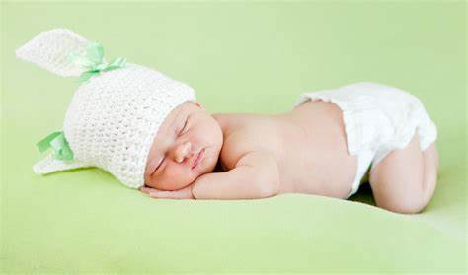
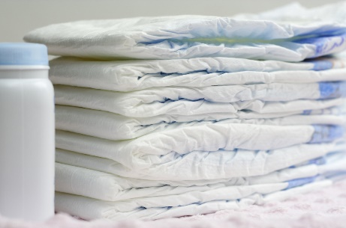
*Some Restrictions Apply



